* **Activity 3:**

Using the INTERSECT Operator

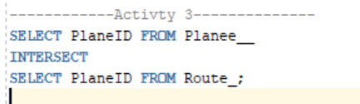

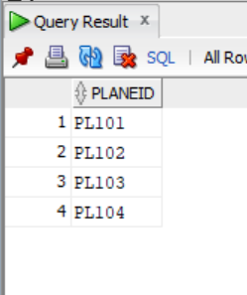OUTPUT: